Testing the input validation on filter fields

1 Non-numeric char in price min textbox

2 Non-numeric char in price max textbox

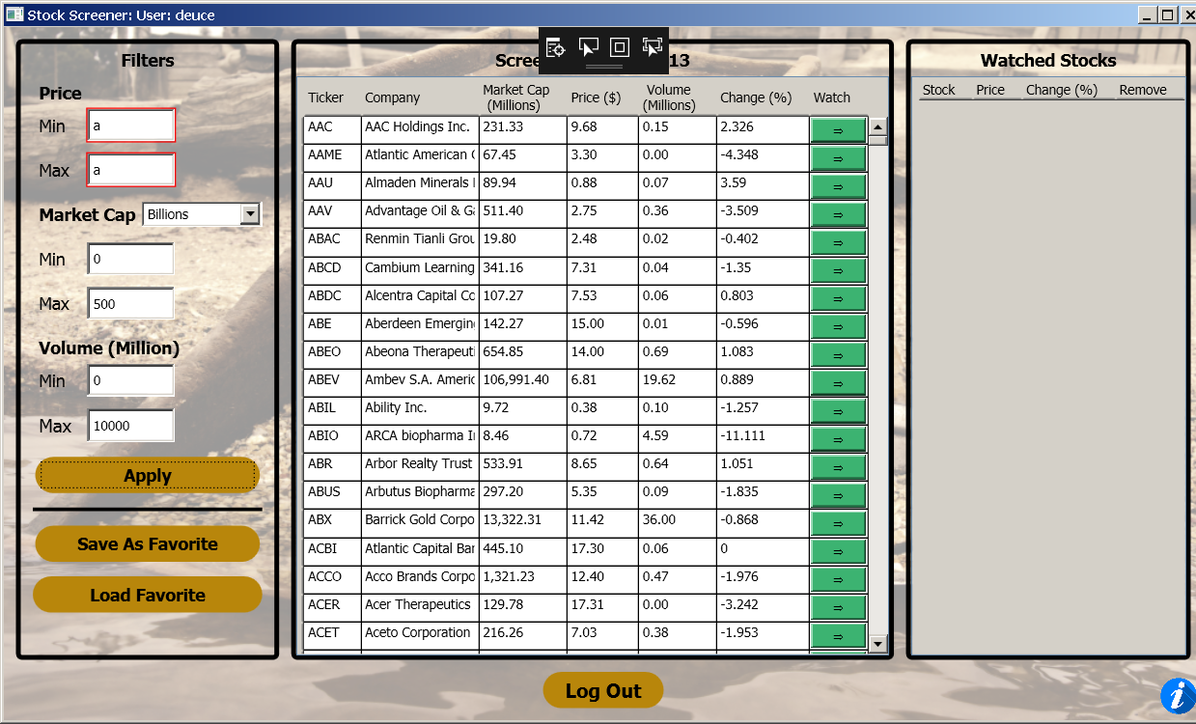

3 Market cap dropdown shows Billion and Million

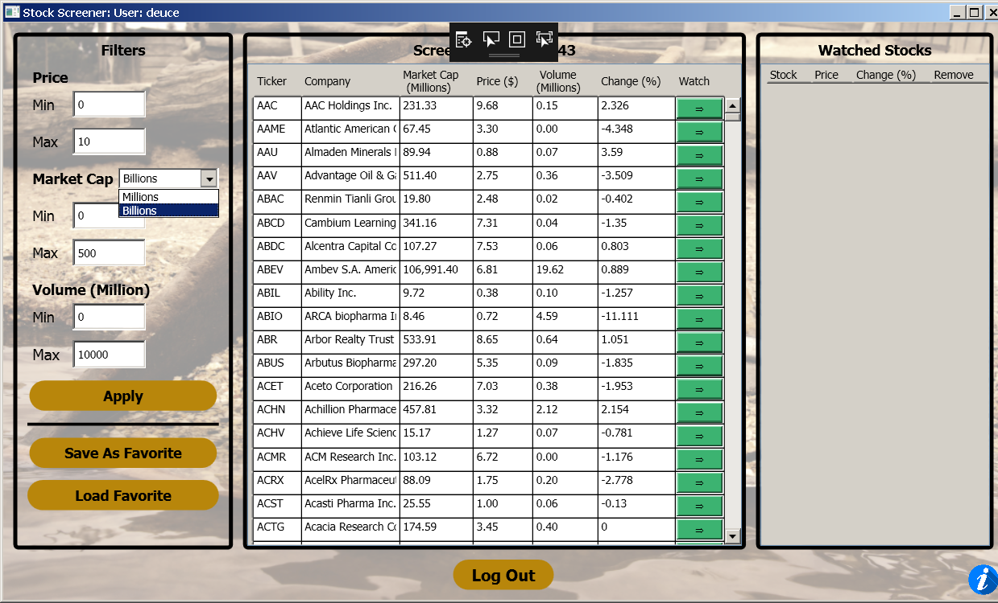

4 Non-numeric char in market Cap min textbox

5 Non-numeric char in market cap max textbox

6 Non-numeric char in volume min textbox

7 Non-numeric char in volume max textbox

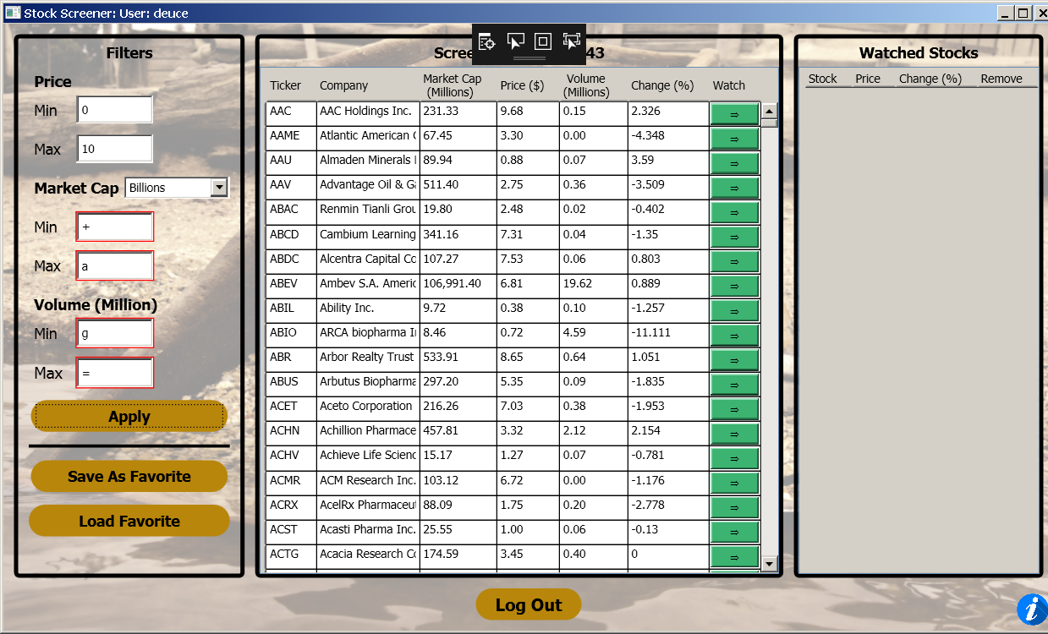

8 Repeat 1-7 with 10.08.09

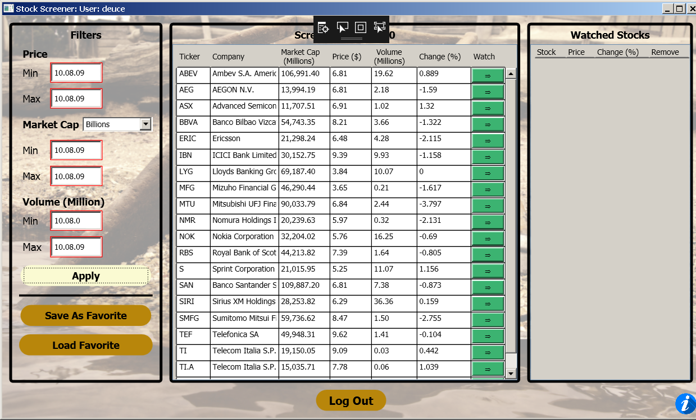

Filter Field Applying

1 Enter “10” in all filter values

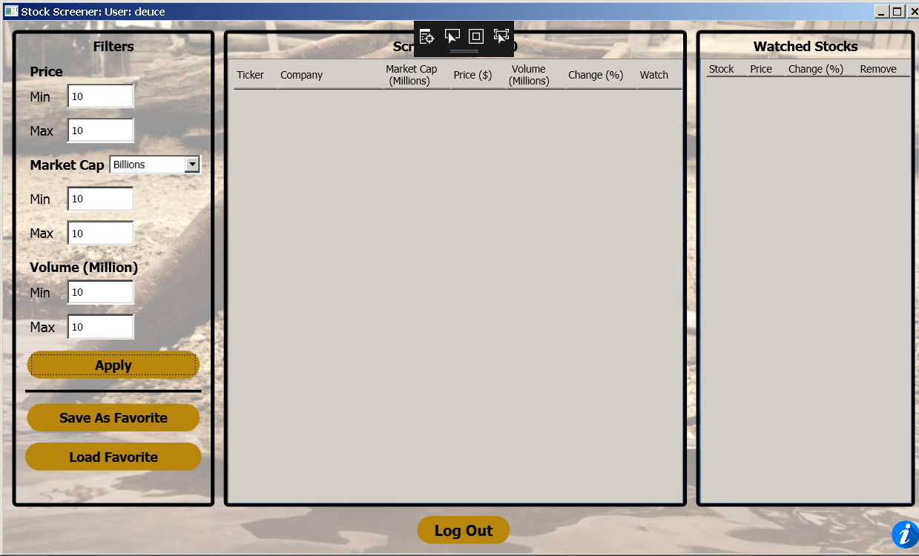

2 Press Apply

(No Screenshot; Apply button functions properly)

3 Log Out of the Application

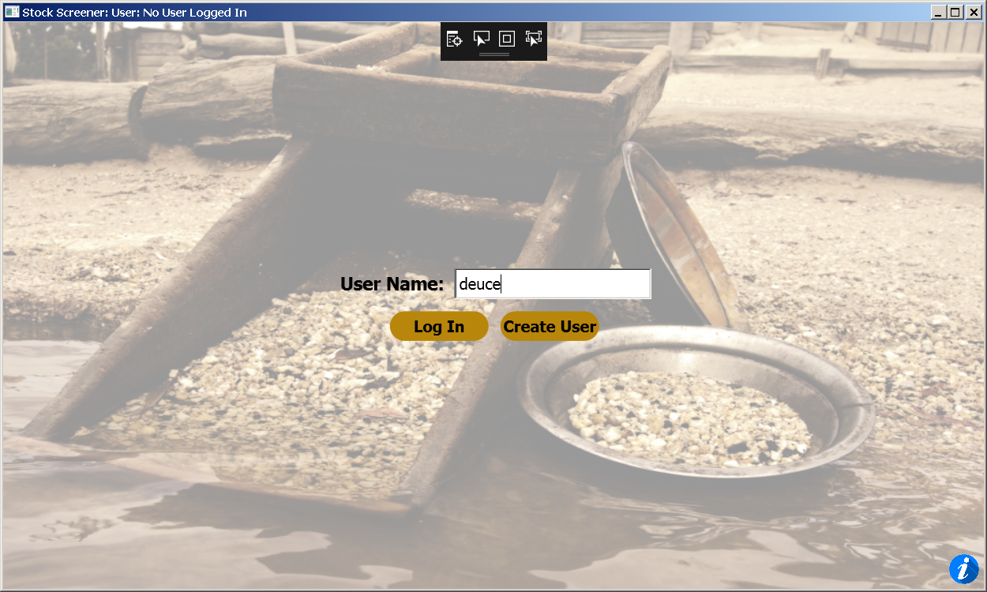

4 Log in with different user

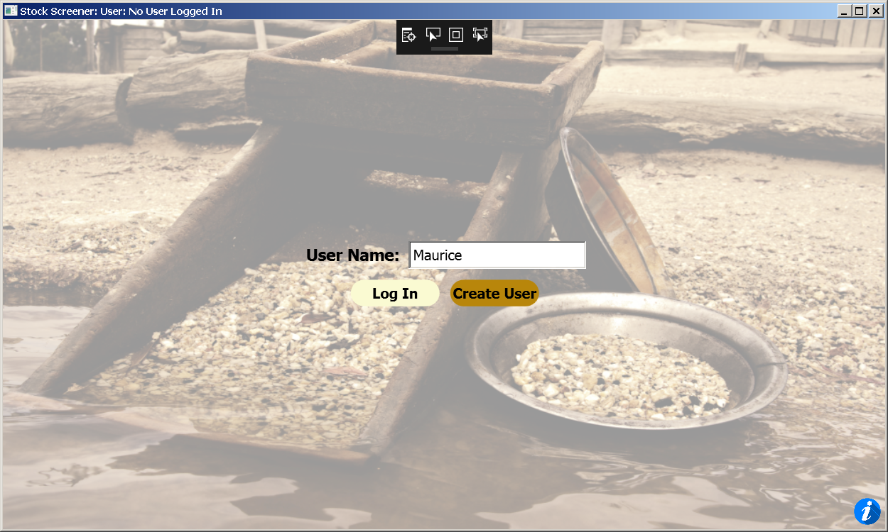

5 Enter test data 15 in Filter textboxes

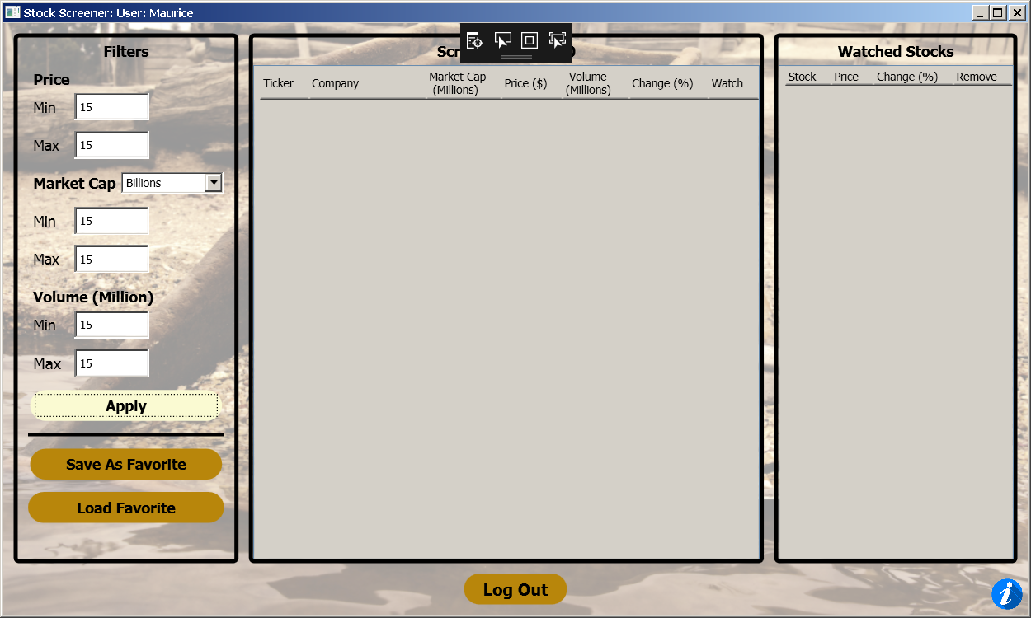

6 Apply (no screenshot)

7 Same as above

Filter field Saving/Loading Favorites

1 Enter value of 11 in all textboxes

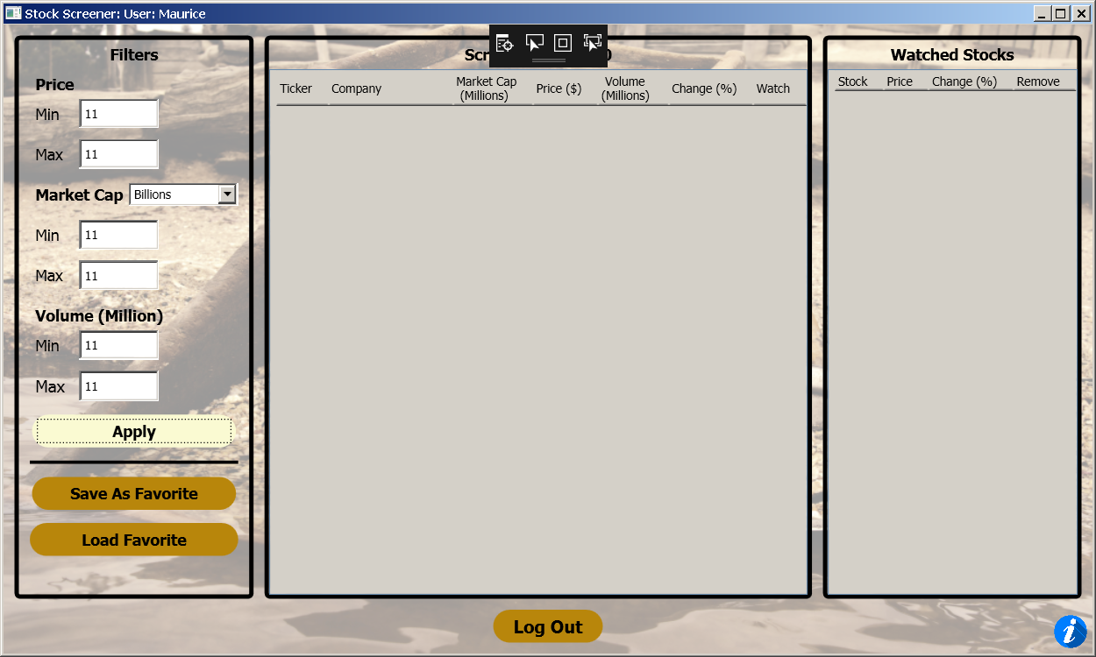

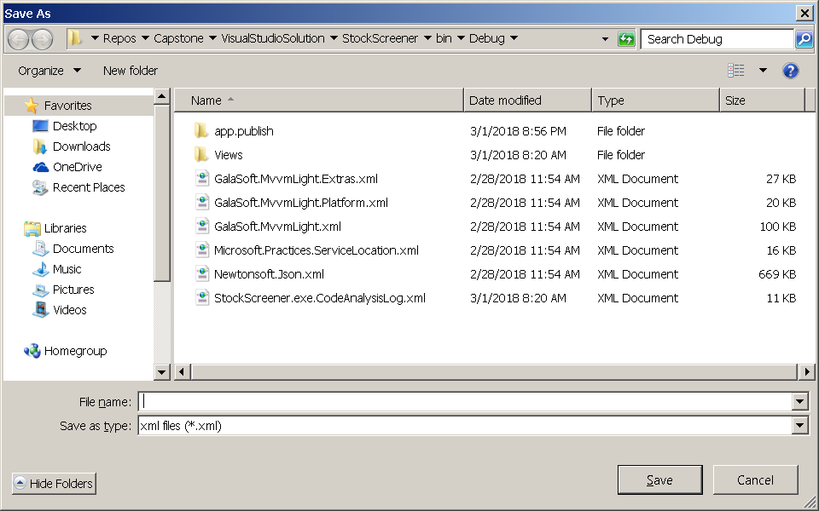

2 Press save as favorite -> successful

3 Name the favorite and save

